# **KAVYA KUMARI RALLAPALLI**

SESHADRI RAO GUDLAVALLERU ENGINEERING COLLAGE

**Data Analytics with Tableau**

23481A4249

**ASSIGNMENT 2:**

AIM: The growth of supermarkets in most populated cities is increasing and market competitions are also high. The dataset is one of the historical sales of supermarket company which has recorded in 3 different branches for 3 months data.

**Creating Below Visualization:**

1. **DONUT CHART:**

**TITLE: INCOME WISE PRODUCT**

**C: Product**

**R: Income**

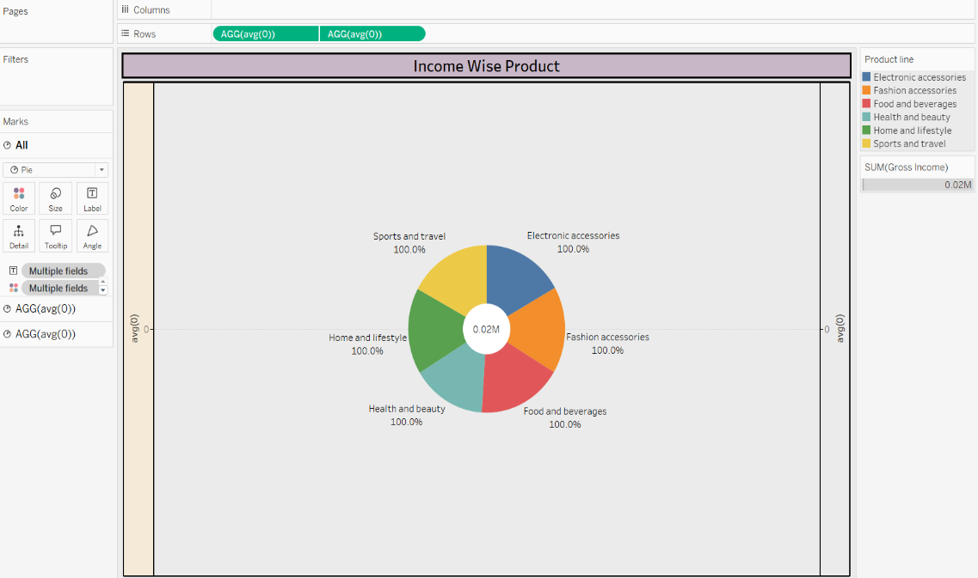

2**. AREA CHART:**

**TITLE: GROSS INCOME IN HOURS OF TIME**

**C: Time**

**R: Income**

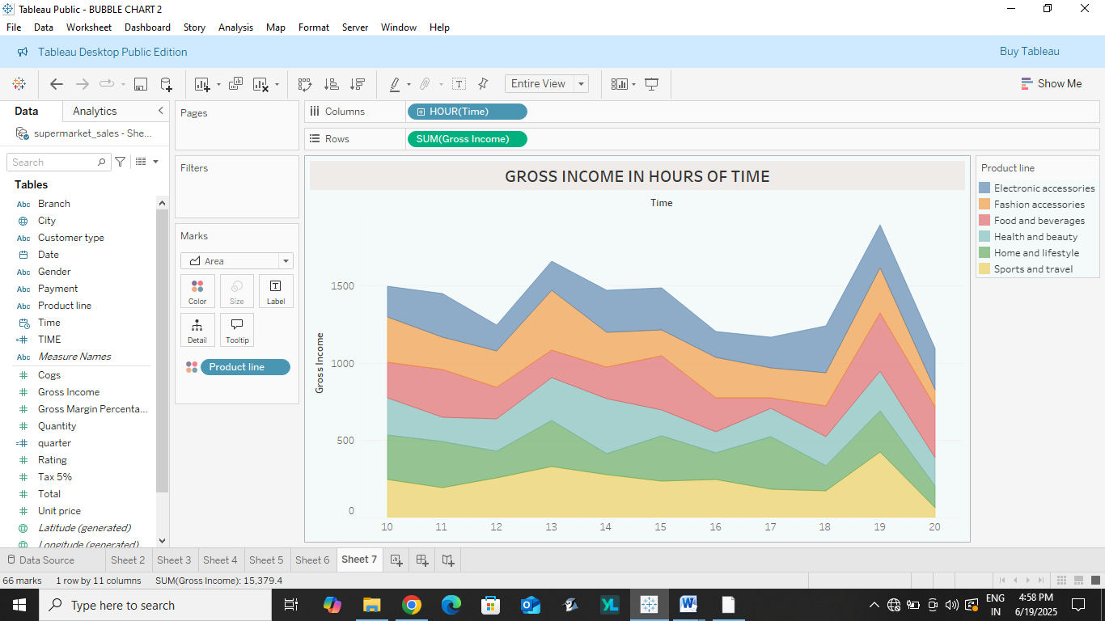

**3** **. TEXT TABLE:**

**TITLE: PRODUCT LINE WITH CATEGORY**

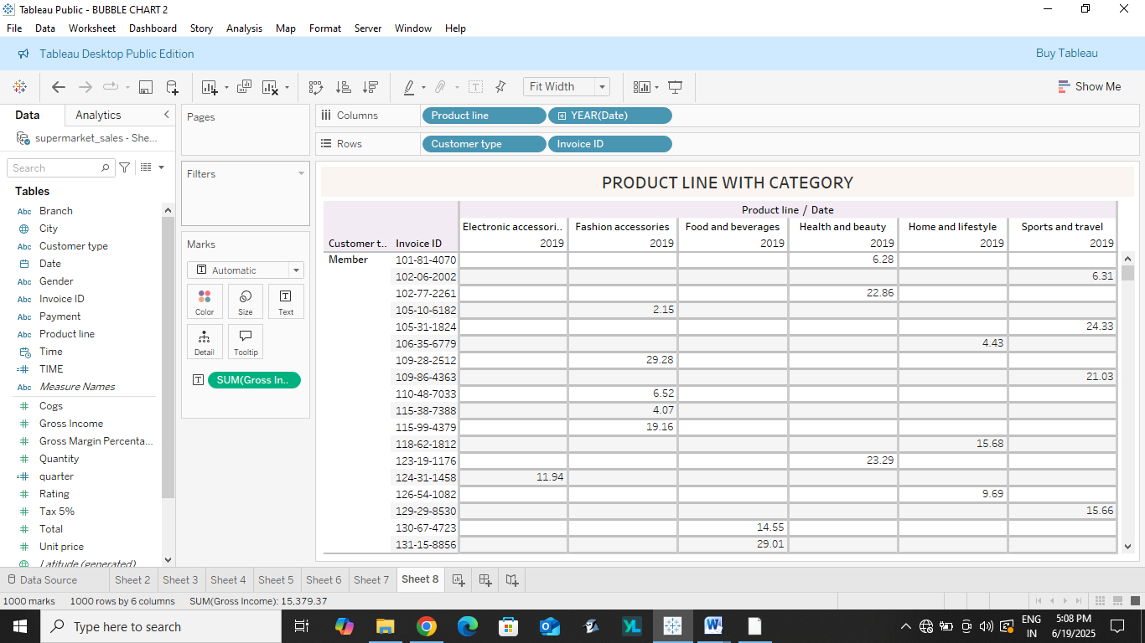

**4. HIGHLIGHT TABLE:**

**TITLE: INCOME WITH CATEGORY**

**C: Quarters**

**R: Income**

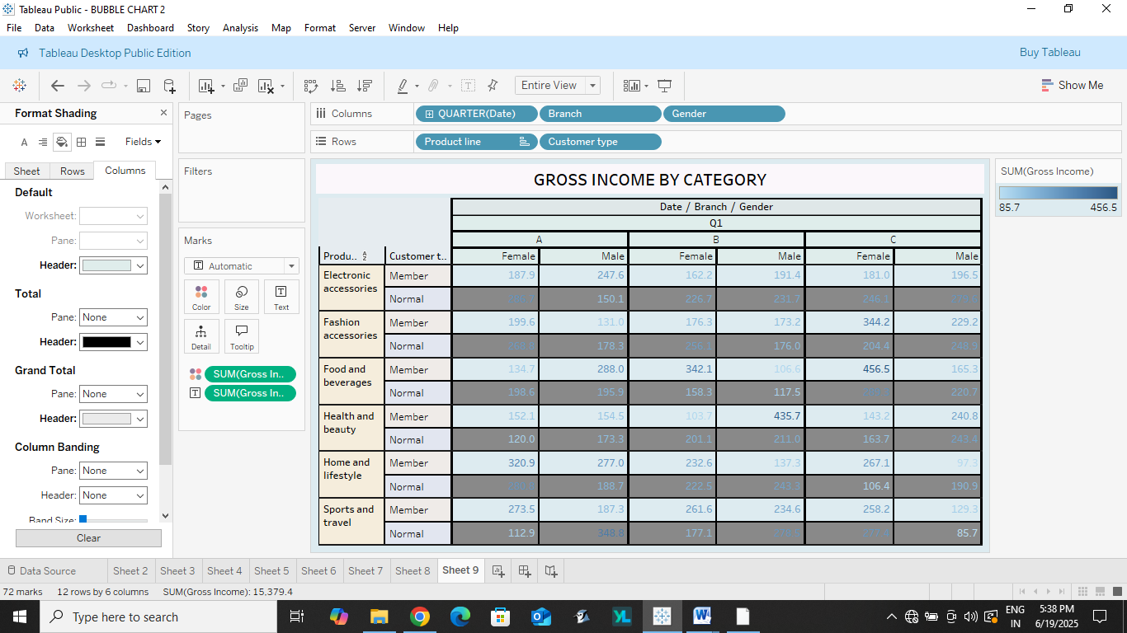

1. **FUNNEL CHART:**

**TITLE: INCOME FOR PRODUCT LINE**

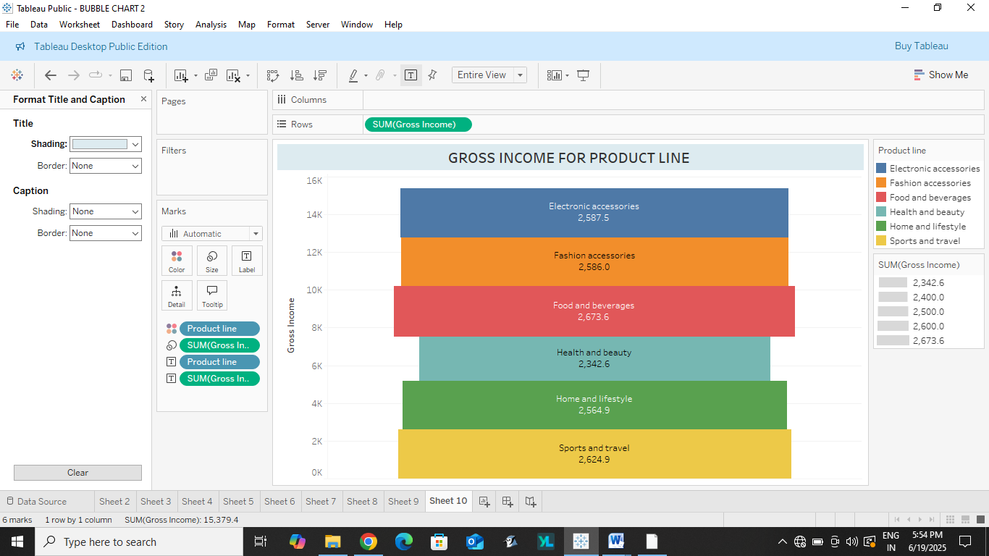

**6** .**WATERFALL: TITLE: INCOME WISE PRODUCT**

